MORNING WORSHIP SERVICE
Nov 8, 2015

Opening Song “America the Beautiful” 630

Opening Prayer/Announcements

Worship Hymns “I Will Sing the Wondrous Story” 537
“You Are My All In All”
“Because He Lives” 407
“Only Believe” 534
“For God So Loved the World”

Offering/Offertory

Special Music

Message Bro. David Atwood
Invitation “Lord, I’m Coming Home” 309
.

Lord’s Supper

Closing Prayer

Evening Service at 6:00

Living Proof Live
March 4-5, 2016 (Fri & Sat)
Waco, TX: Extraco Event Center
Contact Patti Radford if you might be interested in attending

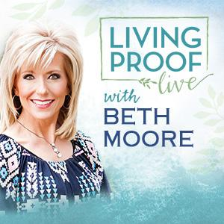
NURSERY – available for children age 0 to Kindergarten
Otisann McManus

Hostesses for November Ushers for November
Shirley Marecle, Judie Coffey, Joe Daniel, Mickey Stanford,
Judy Broussard, Otisann McManus David Condron, Hugo Breithaupt

Immediate Need Prayer List
Prayer & Request Information

(Please complete name & address information on reverse side)

I would like to speak with the Pastor.

I would like more information on this church.

I have Prayer Requests or Needs

Date:

Permission to Publicize:
Church Bulletin Yes No
Email Prayer Chain Yes No

Prayer Request:

Prayer For
Name
Address
Phone

Given By
Name
Address
Phone
Please Contact By

Card Phone Visit

Comments

Pray Bobby and Judie Coffey as Bobby continues to recover.

Pray for Twyla Hughes, Theresa Bartlett’s grandmother, as she has health issues

K s b c

Keeping His Word through Sunday School, Bible Study and Church Attendance/Worship

Sunday School Bible Studies for November:

Nov 1st Stand Courageously Daniel 3:13-18,26-28 Nov 8th Live Humbly Daniel 4:28-35 Nov 15th Confront Sin Daniel 5:17-28 Nov 22nd Act Faithfully Daniel 6:6-10,13-16,19-22 Nov 29th When Opposition Strikes Acts 4:23-31

9:45 a.m. each Sunday – A place for everyone

WE’D LOVE FOR YOU TO JOIN US!

